**Here are some resources that could be helpful for you!**

12-Step Meetings:

Nar-Anon (A 12-Step Program for Family & Friends of Addicts): <https://www.nar-anon.org/>

Nar-Anon Meetings: <https://www.nar-anon.org/find-a-meeting>

Al-Anon (A 12-Step Program for Family & Friends of Alcoholics): <https://al-anon.org/>

Al-Anon meetings: <https://al-anon.org/al-anon-meetings/>

Al-Anon and Alateen Support Groups:<https://www.hazeldenbettyford.org/recovery/families-friends/al-anon-alateen>

Therapist Resources:

<https://www.psychologytoday.com/us>

Psychoeducation:

The 12 Steps of AA Explained (article): <https://www.ashwoodrecovery.com/blog/12-steps-explained/>

12 Steps of Narcotics Anonymous: <https://www.addictiongroup.org/resources/groups/na/12-steps/>

Family Addiction: How Addiction Affects Family & What to Do (article):

<https://americanaddictioncenters.org/guide-for-families-i>

How to Support a Loved One in Recovery (article): <https://rehabs.com/how-to-support-a-loved-one/>

Post-Acute-Withdrawal Syndrome (PAWS): An In-Depth Guide (article):

<https://americanaddictioncenters.org/withdrawal-timelines-treatments/post-acute-withdrawal-syndrome>

Books:

SESH Book (Sharing Experience Strength & Hope) for daily readings/meditations through the Nar-Anon program: <https://www.amazon.com/Sharing-Experience-Strength-Hope-SESH/dp/161584841X>

It Didn't Start with You. (A great book on intergenerational trauma): <https://www.amazon.com/Didnt-Start-You-Inherited-Family/dp/1101980389/ref=sr_1_1?keywords=it+didnt+start+with+you&qid=1650386568&s=books&sprefix=it+didnt+%2Cstripbooks%2C56&sr=1-1>

Videos:

Addiction Neuroscience 101 (video): <https://www.youtube.com/watch?v=bwZcPwlRRcc&list=PLwhPc_nyY2-yMZ_CXJdkYVkNXQREmAYbs&index=35>

Why You Are Addicted (Childhood Trauma) I Dr Gabor Maté:

<https://www.youtube.com/watch?v=NA3pJHEr5ig&list=PLwhPc_nyY2-yMZ_CXJdkYVkNXQREmAYbs&index=2>

Pleasure Unwoven - Self-Stigma:

<https://www.youtube.com/watch?v=JFcAQdEwDhY&list=PLwhPc_nyY2-yMZ_CXJdkYVkNXQREmAYbs&index=3>

Documentaries:

The Mask You Live In <https://www.youtube.com/watch?v=ErOHoTHBf7Q> Fantastic documentary about the pressures of what it means to “be a man” – this video is a little outdated, however, it has a ton of information and sheds light on unspoken truths

Stressed – A Documentary Film. <https://www.youtube.com/watch?v=ahU2FP_b9OQ> great video that explains the connection between the mind and body in regards to stress

**10 Tips for Families in Recovery**

1. **Addiction is a chronic illness,** and, as with any chronic illness, the treatment plan should be managed by professionals, not the patient, to ensure success. Please encourage your family member to follow the residential and after-care program that is recommended. It is the surest way to prevent relapse.
2. **Learn as much as you can about addiction.** Knowledge can boost a family’s sense of hope; education helps escape the blame game. Addiction stems from changes in brain chemistry, not weakness, willfulness or stubbornness. This information might help families to let go of their anger so you can focus on healing.
3. **Connect with peers.** It’s not easy to live with or support someone who has an addiction. Connecting with peers provides a safe, nonjudgmental space for family members to learn, discuss, share, and manage daily life. Al-Anon and Al-Ateen are trusted programs.
4. **Family therapy sessions can help.** Family therapy can breakdown distrust, guilt, and stress in a nonjudgmental environment. Family therapists can help with differentiating between encouraging and enabling.
5. **Prepare meals and eat them as a family.** Even just one meal a week eaten as a family can make a difference. It can help the family to reconnect
6. **Manage expectations.** Addiction is a journey and it can take time for changes and patterns associated with addiction to change. Recovery is a process and it comes with pitfalls.
7. **Try to connect with personal joy.** Find time to do things you enjoy, especially if your life and happiness was intertwined with the addition of a loved one. Taking photographs, volunteering, playing an instrument, joining a book club can all help with reconnecting to your own joy. Meditation is powerful and there are several free apps to start you on a meditation practice.
8. **Exercise regularly and adhere to a regular sleep schedule.** Exercise can deliver big benefits and brisk exercise can help families vent worry and stress in healthy ways. People also need sleep to feel their best, and families assisting with recovery need a good night’s sleep to help cope during waking hours.
9. **Private therapy sessions can help**. Private therapy sessions are a safe place for stressed family members to talk openly and freely about challenges and frustrations. Some of the benefits of therapy include learning coping skills and undoing destructive thoughts that developed during the years of living with a person in active use.
10. **Educate and advocate**. Families can be part of the change by speaking about the truth of addiction with others and helping to remove the stigma. Advocating on behalf of addiction can be life-affirming and healing.

**Regions of the brain and their role in addiction**

There are two regions of the brain that are commonly discussed when it comes to addiction; the pre-frontal cortex and the midbrain. These areas of the brain are two vastly different regions with functional differences that corroborate to maintain homeostasis.

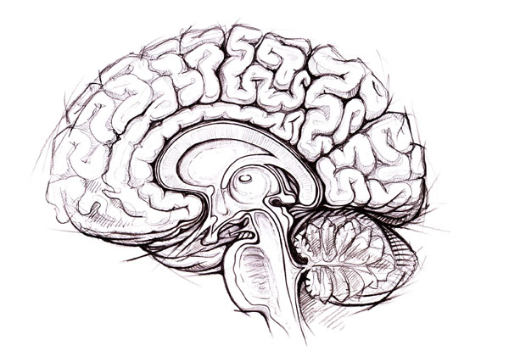The pre-frontal cortex, a region of the cerebral cortex, is charged with rationalizations, decision making, intelligent thoughts, and even one’s moral compass. It is this region of the brain that allows for intellect, a trait that distinguishes us from that of other organisms. One’s conscious thought and personality are also derived from this region of the brain, but most important in the role of addiction is the function of this region to act as a “gatekeeper” of the subconscious brain enforcing the “stop or go” mechanism that drives our instincts, desires, and actions.

The mid-brain sometimes referred to as the primitive or reptilian part of the brain, is located in the mesolimbic region. This works closely with the pleasure center of the brain, tasked with the survival of the species and individual, it is where procreation, hunger, sleep, breathing, waste excretion, and other functions are regulated. This part of the brain has the motto, “If it feels good, do it again”; and so vital functions are rewarded with the release of the neurotransmitters Dopamine and Glutamate which in turn creates a sense of pleasure; respectively creating the feelings of “I want it” and “I like it”. When something works well for survival (take a chocolate cake as an example) the midbrain, through the mechanisms of the dopamine reward pathway, store these outcomes and the mechanism of those outcomes for future use with similar stressors (hunger in this case).

In the mid-brain two areas have been directly linked with addiction; the Nucleus Accumbens and the Ventral Tegmental Area (NA & VTA); both are part of the dopamine reward system. Research has linked addiction to these areas in the brain. Addiction, having its root in the very part of the brain that ensures our survival, is in itself viewed by the body as one of these mechanisms. The fact that the brain recognizes certain chemicals as “survival functions” creates cravings that are more often than not too powerful to ignore. This is why the addict and/or alcoholic will continue to use even when their desire is conflicting. To understand more on how these regions and addiction correlates see. [Psychosocial Aspects](https://www.midwestinstituteforaddiction.org/about-addiction/psychosocial-aspects/)

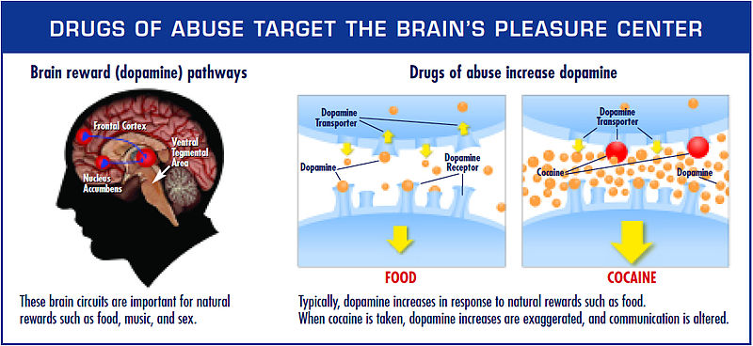

Furthermore, research has shown a decrease in the functioning of the pre-frontal cortex in the alcoholic and addict (remember this is the part of the brain that acts as the gatekeeper). So not only does the individual have deep seeded and powerful desires to continue using but the very part of the brain responsible for rational decision making ceases to function at optimal levels. Take the chocolate cake, for example, we might choose to have a salad instead despite the urge and desire to have something sweet or fatty because of the pre-frontal cortex. The family pet might choose the best tasting treat every time without regard for its health because the pet acts primarily on drives from the primitive area of its brain.

<https://www.midwestinstituteforaddiction.org/about-addiction/the-brain/>

**Psychosocial Aspects of Addiction**

Addiction is caused, in part, by powerful and long-lasting memories of the drug experience and relapse caused by exposure to cues associated with these memories and is a major problem in the treatment process. These memories are a result of information sharing between the prefrontal cortex and the dopamine reward system. When something is found to be efficient and effective in dealing with stressors and maintaining homeostasis it is stored for later reference.

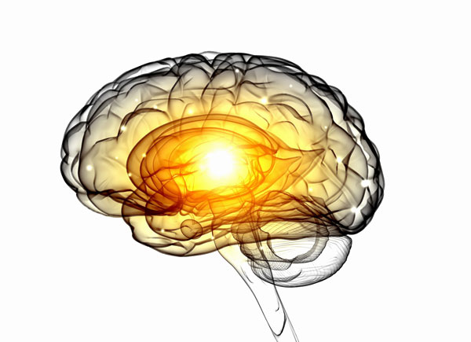For example, a decrease in temperature invokes, for most individuals, the desire to add layers of clothing or cover up with a blanket. This desire is the result of long-lasting and powerful memories stored from learned experiences. The individual is not born knowing that this is the desired response to the stress caused by a decrease in core temperature, yet very likely it is their first impulse.

Similarly, alcohol and drug use are stored in this same way. The prefrontal cortex memorizes the response of the dopamine reward system to the use of the chemical and relates the fact that this is increased from many other stimulants, i.e. it creates greater pleasure than food, fun, family and other forms of recreation; it decreases anxiety; it is effective in acute response to stressors.

This is very important to understand because even after an individual recovers from withdrawal associated with the chemical dependency and physiological adaptations return to normal there is still the presence of these powerful memories to increase the chance of relapse.

Dopamine tells the brain it wants the chemical, Glutamate tells the brain it really likes the chemical, the pleasure center of the brain incites the cue to take action, and the only line of defense is the pre-frontal cortex which is not functioning properly in the alcoholic or addict. This sets the stage for a very difficult journey into sobriety.

Furthermore, a change in the hedonic set point affects an individual’s feeling of wellbeing and euphoria and ability to deal with stress and negative emotions. This change can create a difficult scenario at the early stages of treatment, though this is necessary for the set point to return to natural levels.

<https://www.midwestinstituteforaddiction.org/about-addiction/psychosocial-aspects/>

**Physiological Adaptations of Addiction**

The use of alcohol and drugs can have both acute and chronic effects in the central nervous system, endocrine system, and other systems in the body. Changes can be structural and functional and have adverse effects on one’s health and quality of life. The fact that addiction is defined as a disease, and that it fits so well into this conceptual model, stems from the presence of these adaptations both structurally and functionally.

These adaptations are commonly viewed as tolerance and withdrawal; both common in individuals with prolonged usage of addictive substances. Tolerance is defined as a decrease in response to a chemical with usage over time, at which point increased amounts are necessary to obtain the desired effects. Withdrawal occurs when there is a lack of the chemical within the system and therefore somatic and psychosomatic symptoms occur. The types of symptoms are specific to the type of the withdrawn substance.

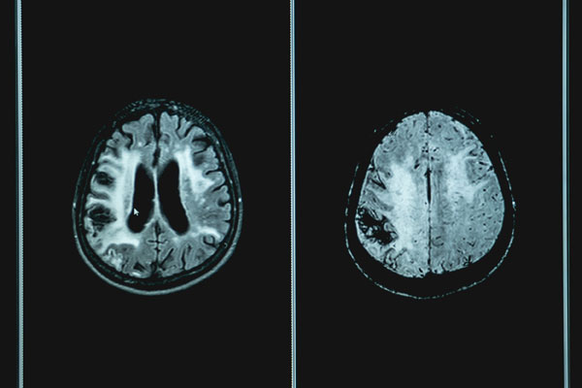  
The cause of all of this occurs at the cellular and molecular level. Neurons work by sending signals back and forth in the CNS (central nervous system) and PNS (peripheral nervous system). These signals are positive charges called action potentials that occur in the neural cell with the influx of Na (sodium) and efflux of K (potassium). Intracellular communication of these neurons occurs at the synaptic cleft. It is here that the presynaptic neuron releases neurotransmitters that bind to receptor sites on the postsynaptic neuron causing excitation to occur in the postsynaptic neuron.

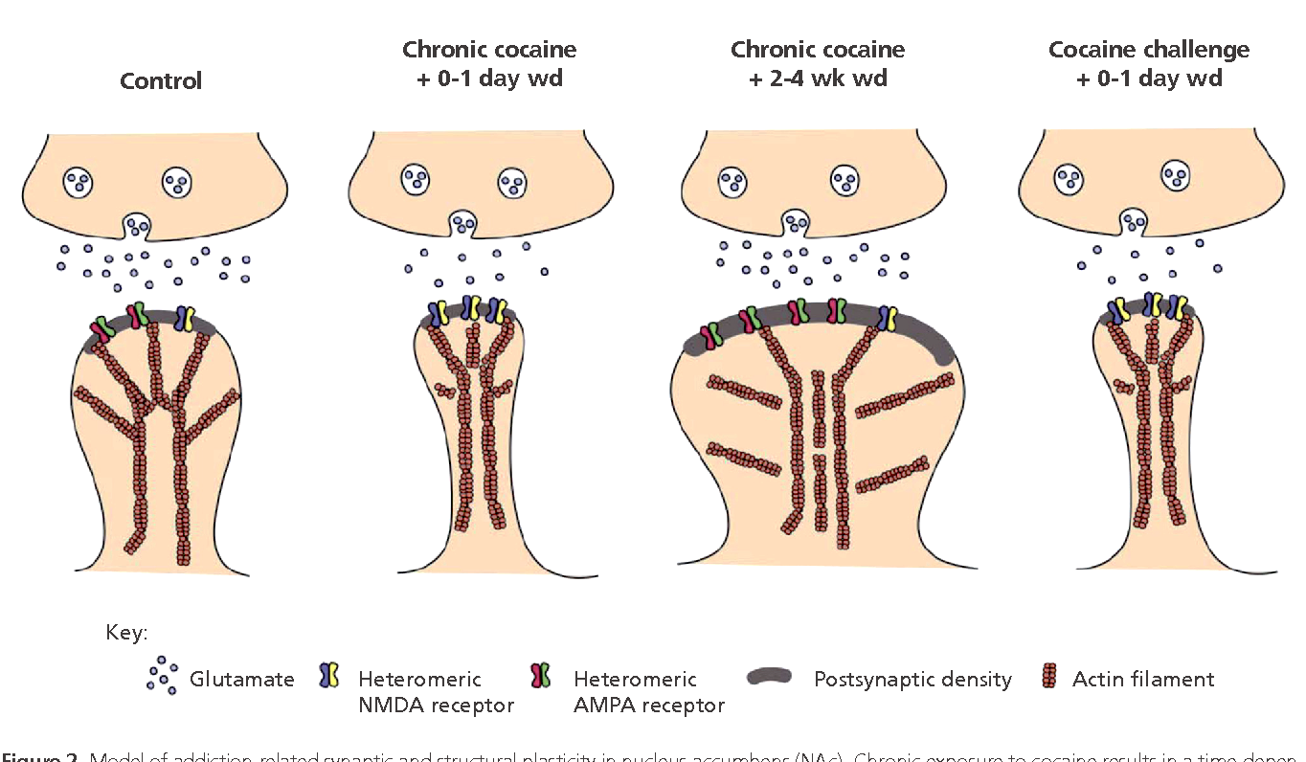Prolonged use of alcohol and drugs can have adverse effects on the receptor site density on these neurons and is seen as tolerance and withdrawals in addicts and alcoholics when available neurotransmitters are decreased through decreased use of the drug of abuse. These structural changes to the cell are what the addict and/or alcoholic experience as both tolerance and withdrawal. It is important to note that not only does this disrupt homeostasis throughout the bodies systems but it also decreases the individual’s cognitive functioning; most notable being that of the prefrontal cortex. In reference to the [brains](https://www.midwestinstituteforaddiction.org/about-addiction/the-brain/) functions, lack of cognitive ability means a decrease in reasoning, therefore an increase in poor decision making and a high likelihood of alcohol and/or drug use or relapse.

Physical aspects of alcohol and drug addiction are some of the initial hurdles an individual must get over as they begin their treatment. The good news is that the majority of structural and functional changes revert back to normal with enough time without alcohol and/or drugs; this means cognitive functioning and good decision making will increase over time in a rehab program. Because of a deviation in the system, other effects of chronic chemical use can occur including chemical imbalance causing depression, anxiety, insomnia, etc… and changes in the hedonic set point affecting an individual’s quality of life and ability to deal with stress and emotion.

https://www.midwestinstituteforaddiction.org/about-addiction/physiological-adaptation